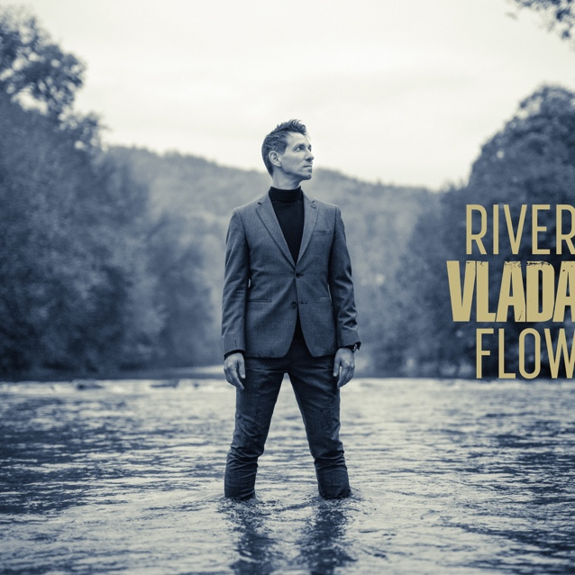
RIVER FLOW
Label Glad Vlad Records
UPC 4062851857369
ISRC QZHNA1981089
Release 21st February 2020
Genre Pop, Soul
Sounds like George Michael, Stevie Wonder,
Jamie Cullum, Earth Wind & Fire

BIOGRAPHY

Many dreams came true when soul singer VLADA recorded his debut album All About You with some of his biggest heroes, such as ten-time Grammy Award winning Take 6 as well as world-class musicians Abraham Laboriel, Paul Jackson Jr., Vinnie Colaiuta, and Kirk Whalum. But let’s go back a few decades: Raised in Switzerland to a Serbian family, VLADA was fascinated with all things groove from an early age. Soulful black sounds from the likes of Stevie Wonder, James Brown, Aretha Franklin, and Nat King Cole made him move inside and out. They made him sing, too, and so VLADA got seriously involved with the contemporary gospel music scene. He started writing his own songs as well, which by God’s grace led to the aforementioned and acclaimed debut album All About You in 2010, a powerful and unique blend of soul, funk, gospel and pop featuring an all-star cast that surpassed VLADA’s wildest dreams and that got him radio airplay and TV appearances in the USA and in Europe.
After living in New York City and Nashville for five years and giving over 100 concerts in the US and Canada, VLADA moved back to Switzerland in 2012 to get married to the love of his life and has since become a proud father of two sons. VLADA had been writing new material with his old friend and pianist Andreas Hausammann for some years when the two of them decided in 2019 that it was finally time to record a selection of new songs. With renowned German bass player Marc Ebermann and drummer Matthias Meusel to complete the band, VLADA recorded his new EP River Flow (2020) in an old-school live setting that organically compliments his songwriting and singing approach. VLADA wrote the title track after various couples around him separated or got a divorce. River Flow talks about heartbreak, loss and letting go, but at the same time it offers hope for healing and new love.

River Flow www.vlada.ffm.to/riverflow
Website www.vladamusic.com
Facebook www.facebook.com/vladaofficial
Instagram www.instagram.com/vladamusic
YouTube www.youtube.com/vladamusicTV
Spotify www.vlada.lnk.to/Spotify
Apple Music www.vlada.lnk.to/AppleMusic
Contact
VLADA | info@vladamusic.com | +41 62 824 71 71

